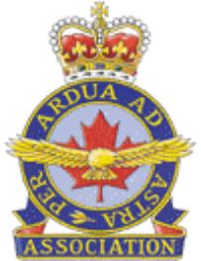

ROYAL CANADIAN AIR FORCE ASSOCIATION
ASSOCIATION DE L’AVIATION ROYALE CANADIENNE
Advocacy, Heritage, Youth, Community – Promotion, Héritage, Jeunesse, Communauté

NEC GENERAL MEETING
VIDEO/TELECONFERENCE

AGENDA - 26 FEB 17

- Call meeting to order/Opening
- Approval of minutes of previous General Meeting(s)
- Correspondence

REPORTS

NEC Updates

- Chairman/President’s Report
- Honorary National President’s Report/ Advocacy Committee
- Vice Chairman/Vice president’s Report
- Treasurer’s Report/Financial Update
- Executive Director’s Update
- Veterans’ Liaison
- MALs
- Membership
- Communications
- Aviation Heritage
- Air Cadets
- Ceremonial
- RCAFA Trust Fund

Group Updates

Other Reports

UPCOMING NATIONAL EVENTS

Air Force Day on the Hill – 9 May 2017

OLD BUSINESS

Follow-up from AGM – Action items
Status of current association constitution and by-laws
Virtual Wings
NEC Position Descriptions
Group AGM dates

NEW BUSINESS

Strategic Plan – Focus Discussion

Info only:
Communications Plan
Membership Plan
Training Plan
Development of a five year Consolidated Plan
Resolutions Process
Future AGM plan (Face-to Face and Electronic)

Meltwater (Media software)– unsolicited proposal
AIAC - Corporate Membership
Wing membership returns and remittances (Reporting)
Warsaw Wing update (Banner ownership)

CONCLUSION

Set next NEC General Meeting (Teleconference – Mar 2017)

Set date of next focus group for NEC

End of Business and Closing

